Sales Analysis Project
An end-to-end Sales Data Analysis project that demonstrates a practical data analytics workflow: raw data cleaning with Python, loading the cleaned data into MySQL, and building a Power BI analysis/dashboard from the prepared dataset.
Project Overview
This project takes raw sales transaction data and transforms it into a cleaner, analysis-ready dataset.
The workflow includes:
- Raw sales data stored in Excel
- Data cleaning and transformation using Python and Pandas
- Derived columns for Profit, Year, and Month
- Cleaned data export to CSV
- Loading the cleaned dataset into MySQL
- Sales analysis and visualization using Power BI
The raw dataset contains 500 rows and 7 columns. After cleaning, the analysis-ready dataset contains 482 rows and 10 columns.
Data Cleaning
The raw Excel dataset contains the following fields:
- Order_ID
- Order_Date
- Customer
- Region
- Product
- Sales
- Cost
The cleaning process was performed with Pandas. 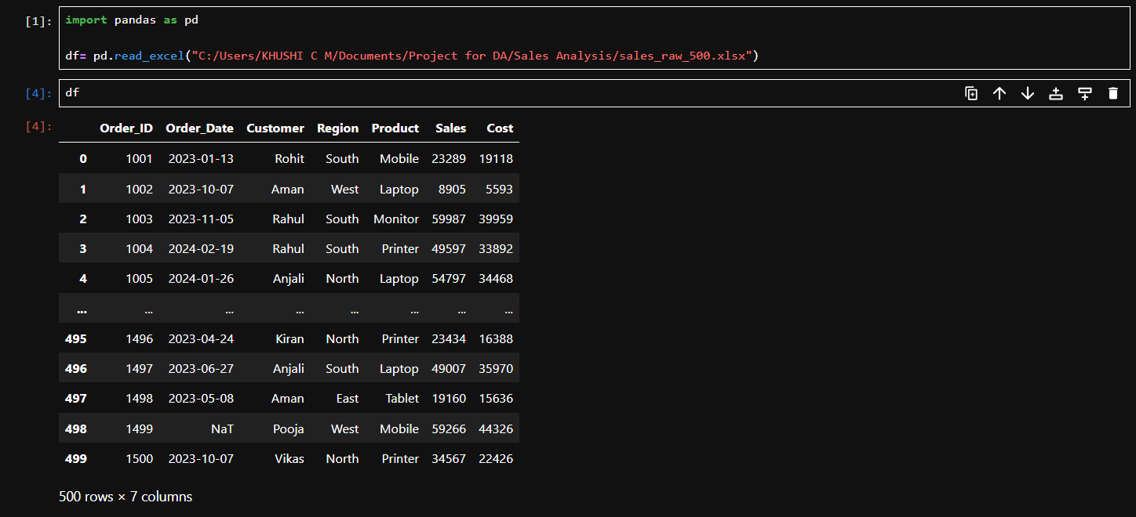
Cleaning steps
- Loaded the raw Excel dataset with Pandas.
- Removed duplicate records using drop_duplicates().
- Converted Order_Date to a datetime format using pd.to_datetime().
- Removed records where Order_Date could not be interpreted as a valid date.
- Calculated Profit using: Profit = Sales - Cost
- Extracted Year from Order_Date.
- Extracted Month from Order_Date.
- Exported the cleaned dataset as sales_cleaned.csv.
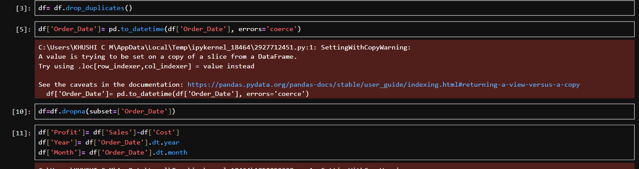
The resulting dataset contains:
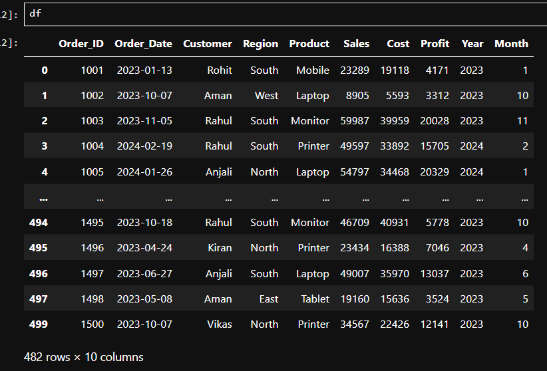

SQL Database
The cleaned CSV data was loaded into a MySQL database named salesdb.
The SQL workflow includes commands to:
- Create the salesdb database
- Select the database
- Inspect available tables
- Query the sales_data table
- Count records in the table
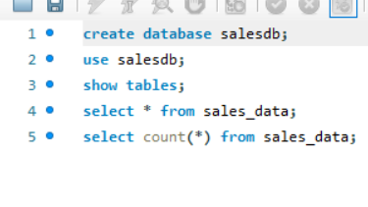

Power BI
The cleaned sales data was used as the basis for the Power BI analysis.
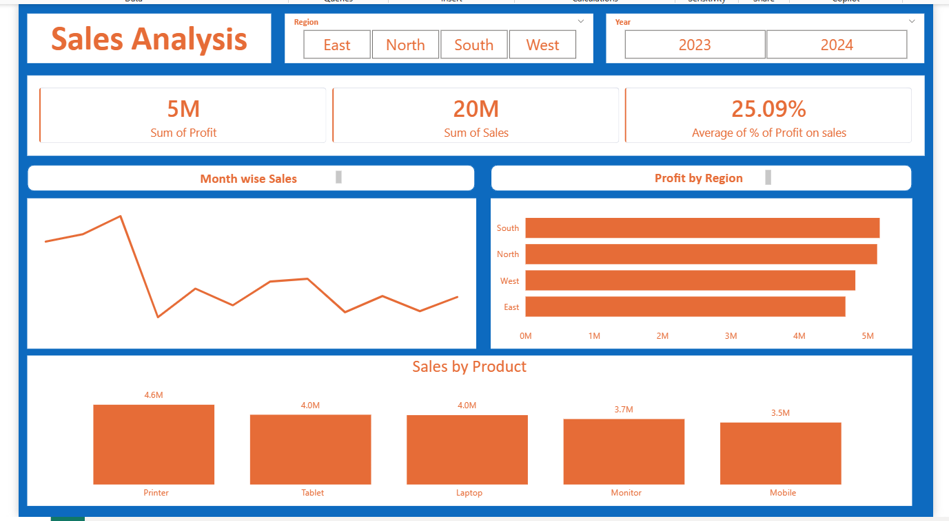

Key Learning Outcomes
This project demonstrates practical experience with:
- Data cleaning using Python and Pandas
- Handling invalid date values
- Removing duplicate records
- Feature/column creation
- CSV data preparation
- SQL database creation and querying
- Loading Pandas DataFrames into MySQL
- Connecting different stages of a data analytics workflow
- Preparing data for business intelligence and visualization in Power BI
Future Improvements
Possible improvements include:
- Adding more detailed SQL analysis queries
- Creating additional calculated measures in Power BI
- Adding interactive filters and drill-down analysis
- Adding automated data validation checks
- Improving the data-cleaning notebook to use safer .loc assignments
- Adding screenshots of the final Power BI dashboard
- Publishing a live Power BI report where appropriate
Author
Khushi Chhanna Meshram

